**EXTRA CREDIT**

Installing MAVEN :

Step 1 : In a terminal, run apt-cache search maven

Step 2 : Run command sudo apt-get install maven

Step 3: mvn –version

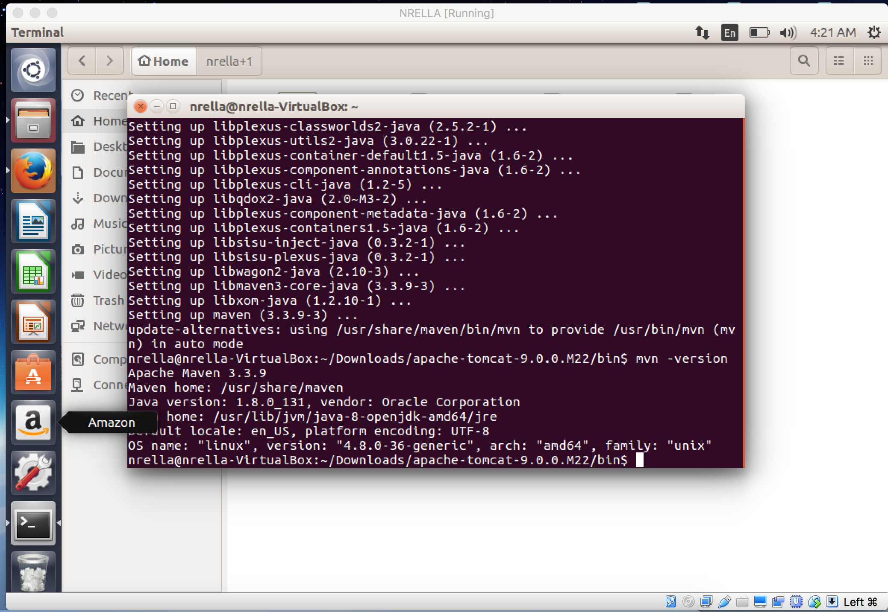

Command **ENV**

